To Install Python 3.11: -

* Firstly clone <https://github.com/JetsonHacksNano/build_python.git> repository to jetson nano.
* Then, go into that folder using cd command and then bash using

$ bash ./build_python3.sh

* Build took almost 2 hours to complete.
* Next step, write following commands

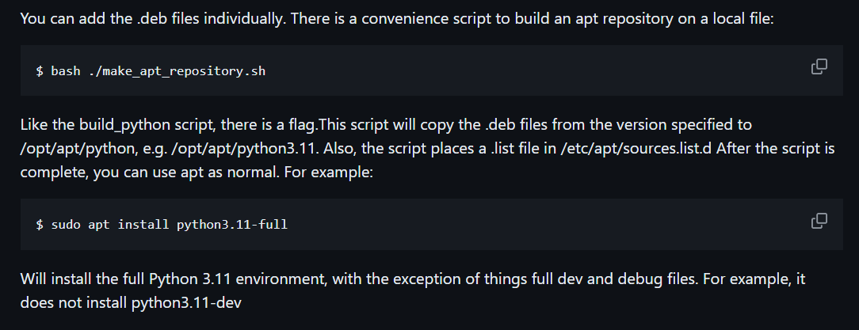

* Now, let’s install pip: - python3.11 -m ensurepip –upgrade.
* Make a new project directory named elc using mkdir elc, switch over to that directory using cd elc.
* Make a virtual environment named venv using command: -python3.11 -m venv .venv
* To activate virtual environment.

Command: - source .venv/bin/activate

* To deactivate environment, use command: - deactivate.

Refer this YouTube video for any other help: -<https://www.youtube.com/watch?v=LSdXakt8nZ8>

To install Jupyter Notebook: -

* To install jupyter notebook: - pip3 install jupyter.
* To run Jupyter notebook, write a command: - jupyter notebook.

To run Code on our Jetson Nano: -

* Open the terminal on Jetson Nano.
* Go into elc directory using cd elc.
* Activate the virtual environment using: - source .venv/bin/activate
* Write jupyter notebook command for running Jupyter notebook.